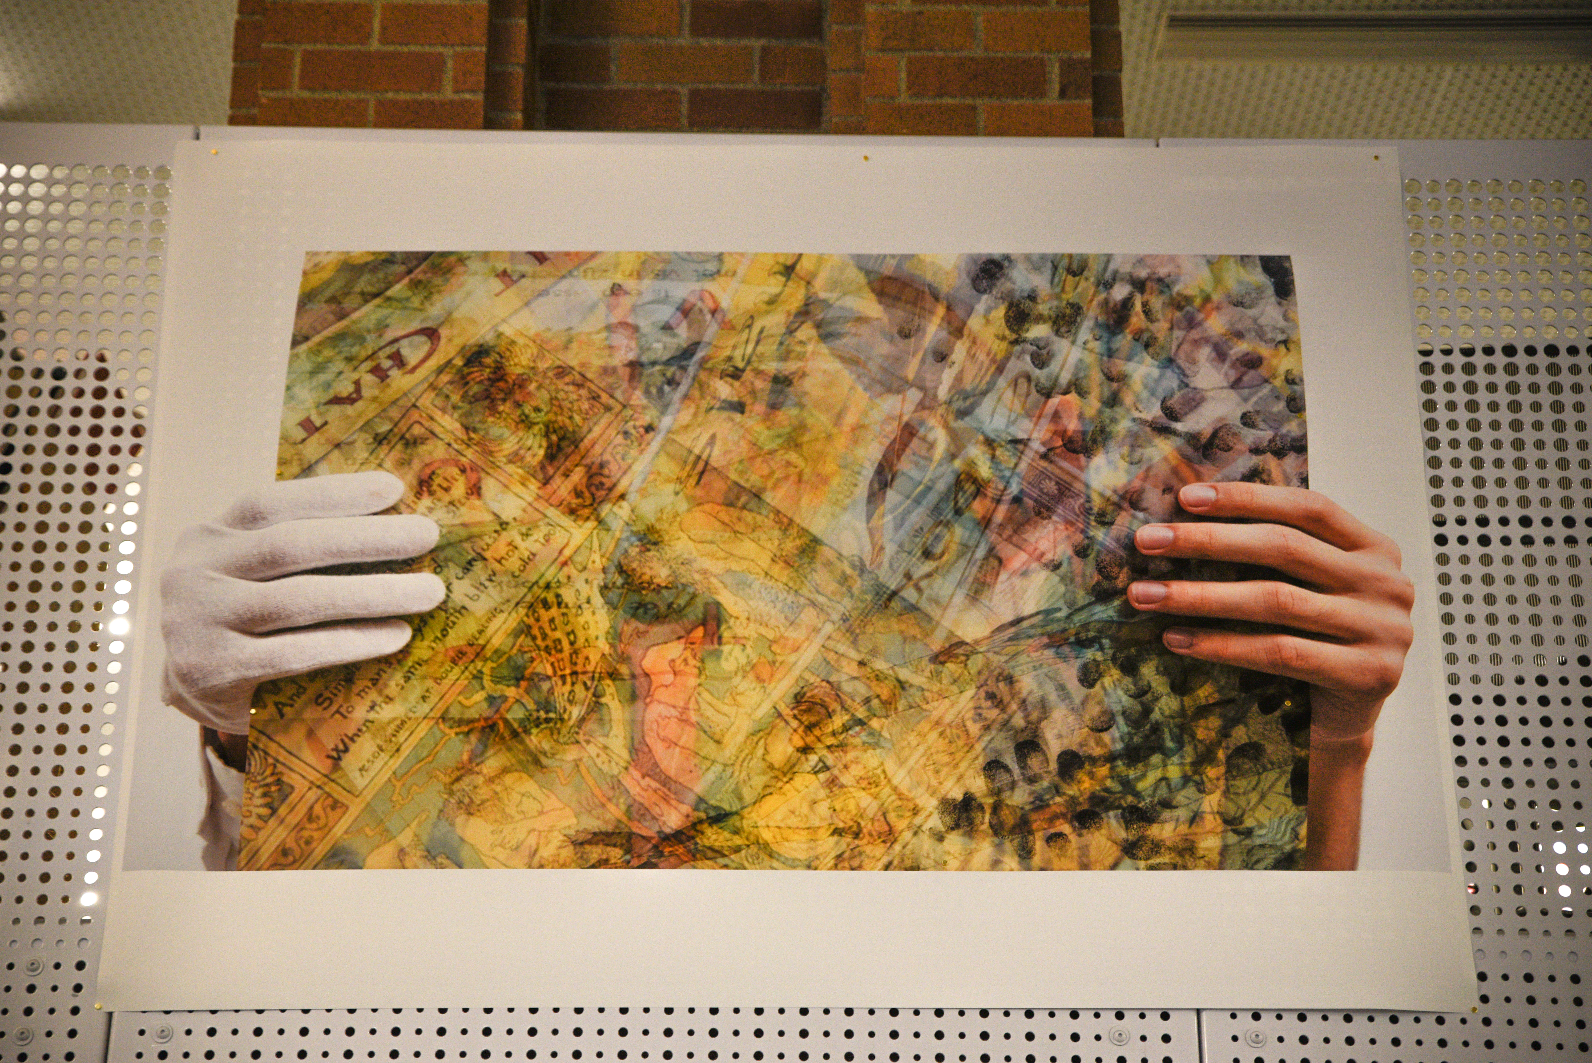

Paper & Ink

60” x 40”

Received: 3.8

Time Spent: 6 hours

Initial Reaction: 8/10

Cost of Materials: $55

This work was received well in crit and received an overall grade of 3.8 upon evaluation. The total hours/money spent on labor and cost of materials was below average.

Add To Cart: **$1255** [See Pricing Sheet](Pricing%20Sheet.docx)



Website

? x ?

Received: 3.8

Time Spent: 7 hours

Initial Reaction: 7/10

Cost of Materials: $0

This work was received fairly well in crit and received an overall grade of 3.8 upon evaluation. The total hours/money spent on labor and cost of materials was below average.

Add To Cart: **$105** [See Pricing Sheet](Pricing%20Sheet.docx)



Video

? x ?

Received: 3.8

Time Spent: 4 hours

Initial Reaction: 6/10

Cost of Materials: $0

This work was received okay in crit and received an overall grade of 3.8 upon evaluation. The total hours/money spent on labor and cost of materials was below average.

Add To Cart: **$60** [See Pricing Sheet](Pricing%20Sheet.docx)

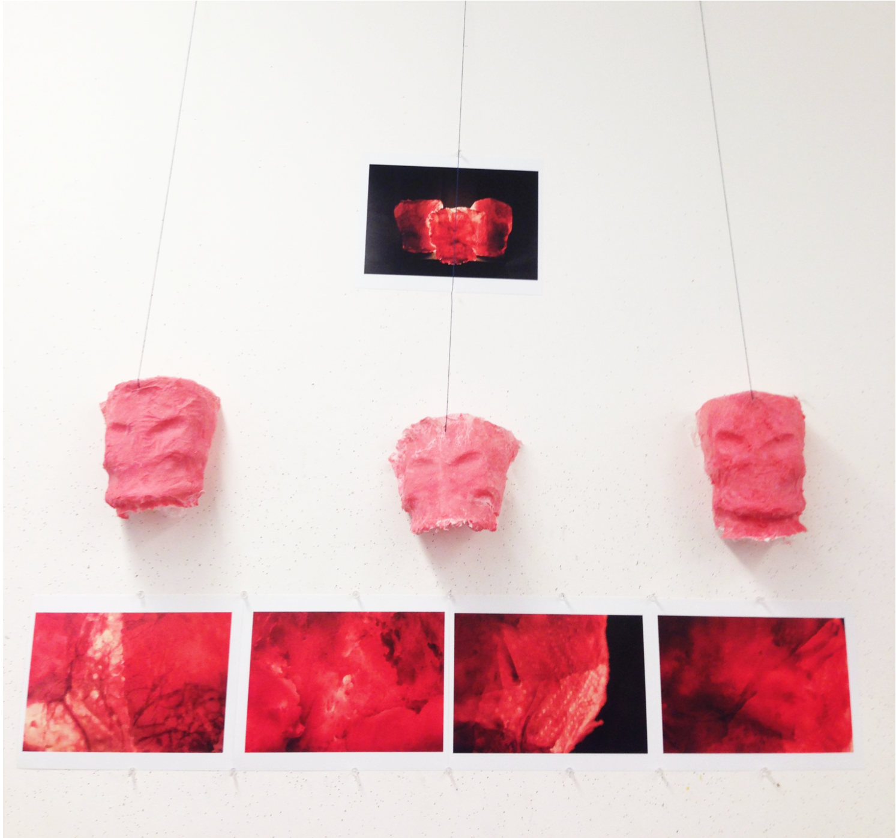

Wax, Paper & Ink

8.5”x11”

Received: 3.8

Time Spent: 8 hours

Initial Reaction: 7/10

Cost of Materials: $23

This work was received fairly well in crit and received an overall grade of 3.8 upon evaluation. The total hours/money spent on labor and cost of materials was below average.

Add To Cart: **$143** [See Pricing Sheet](Pricing%20Sheet.docx)